1. Запросы, выводящие информацию по конкретному пациенту: его хронические заболевания и их лекарственная терапия. Данные этого запроса могут служить как для информации о базисной терапии получаемой пациентом, так и служить оценкой доктору - соответствие диагноза и назначенной терапии последним принятым рекомендациям.

SELECT ch.case_history, m.illness, st.surname, ch.date_update, d. tradename, d. active_substance, ch.use_drug FROM chronic_illness AS ch, MKB_10 AS m, medical_staff AS st, drug AS d WHERE ch.case_history = 99 AND ch.MKB_10_code = m.code AND ch.doctor_id = st.id AND ch.basis_drug_id = d.id AND ch.assigned = 'accept' ORDER BY m.illness, date_update \G;

SELECT ch.case_history, m.illness, st.surname, d. tradename, d. active_substance FROM chronic_illness AS ch, MKB_10 AS m, medical_staff AS st, drug AS d WHERE ch.case_history = 99 AND ch.MKB_10_code = m.code AND ch.doctor_id = st.id AND ch.basis_drug_id = d.id AND ch.assigned = 'accept' ORDER BY m.illness, date_update;

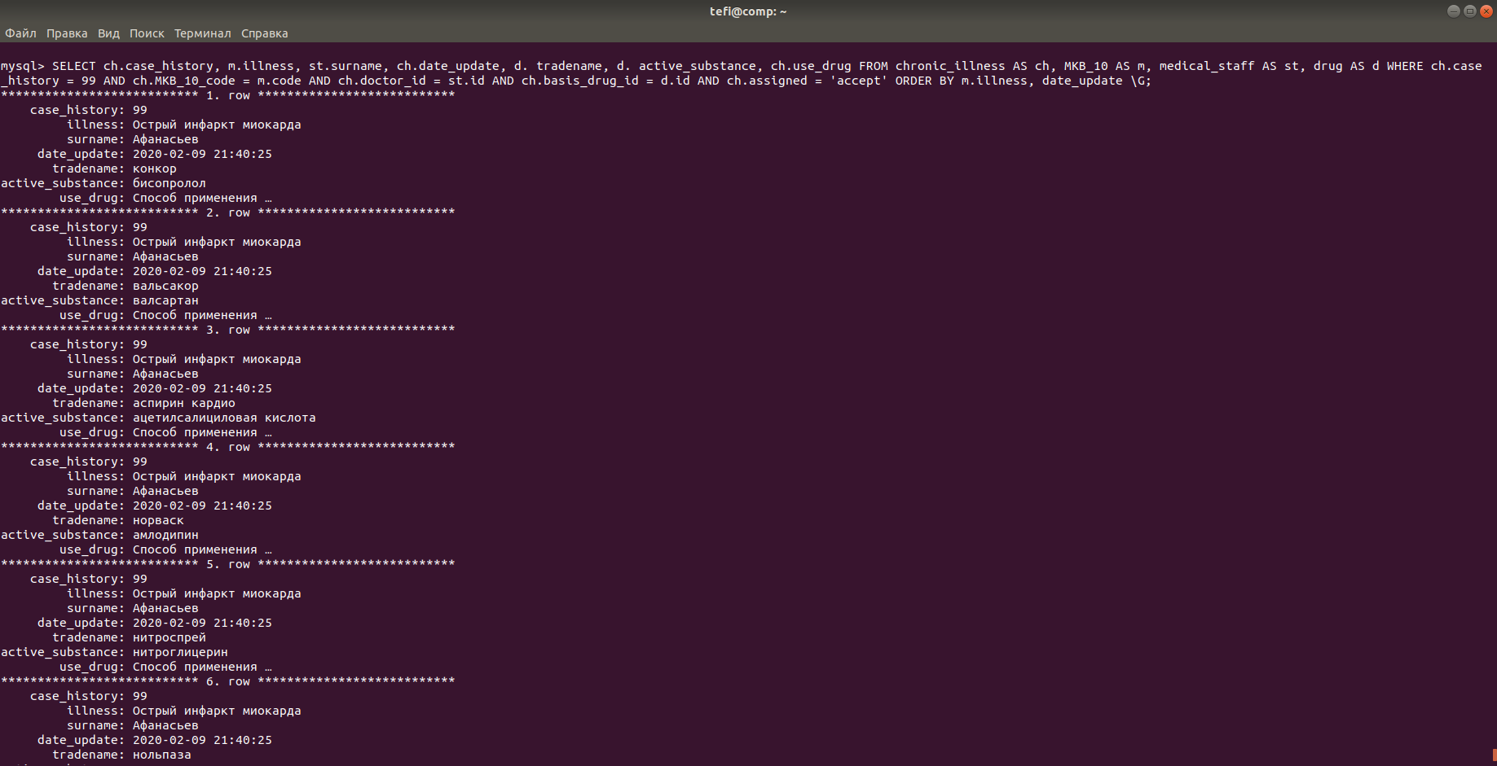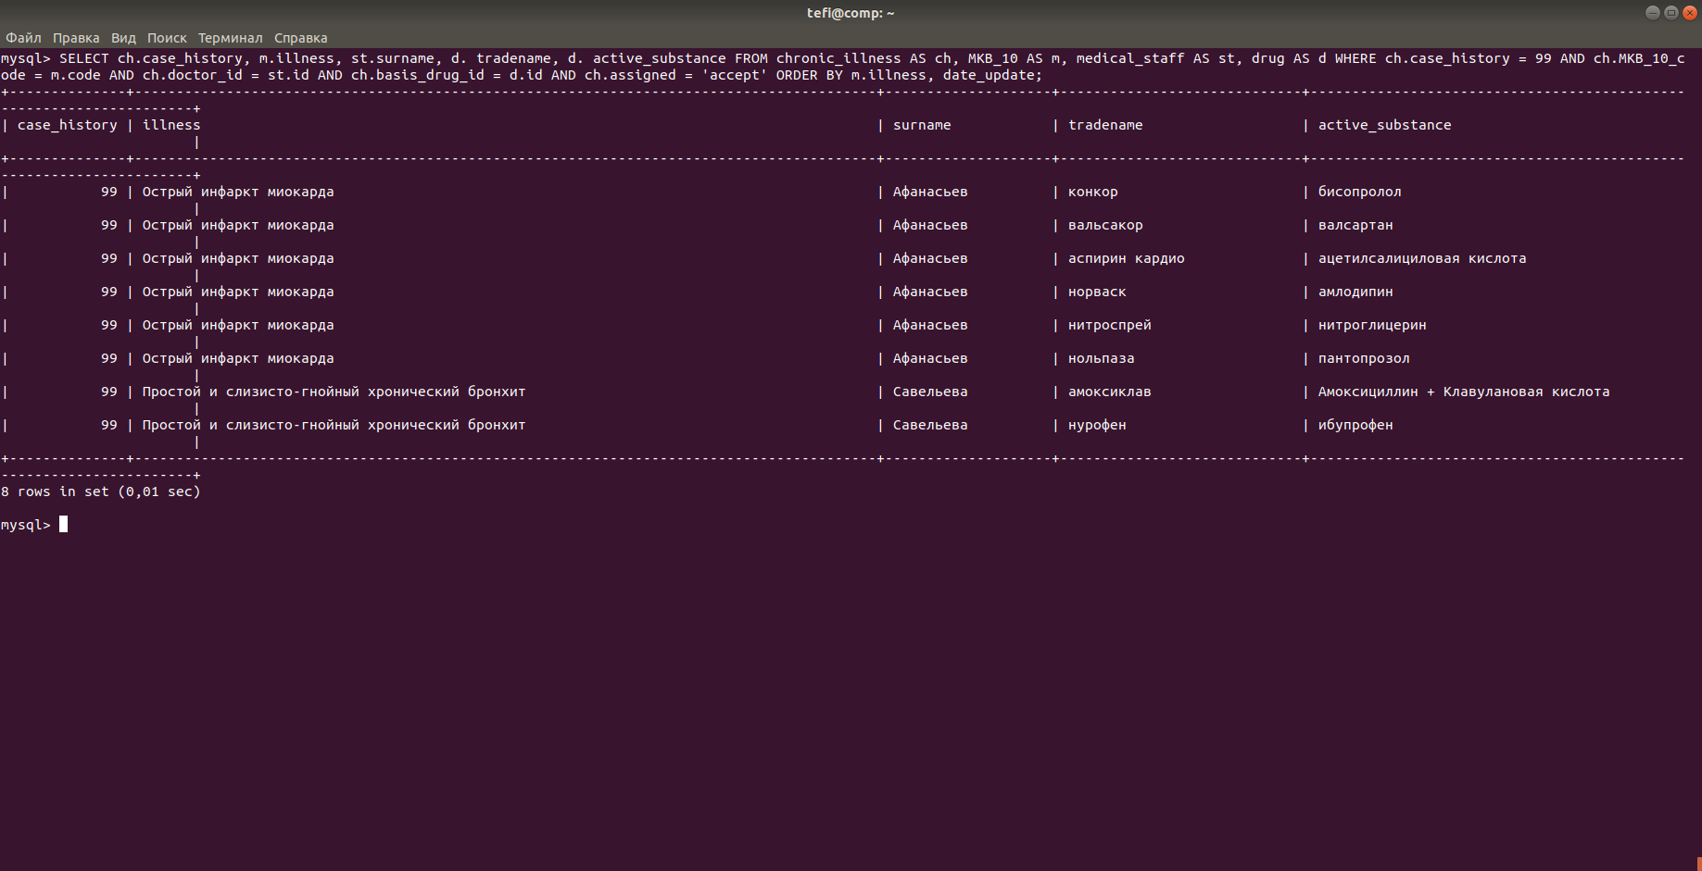

1. Запрос, выводящий все имеющиеся результаты обследования у данного пациента.

(SELECT c.case_history, cn.name, c.date_executed, c.result_link, c.norma

FROM clinical_diagnostic AS c, clinical_diagnostic_name AS cn WHERE c.case_history = 45 AND cn.id = clinical_diagnostic_id)

UNION

(SELECT r.case_history, rn.name, r.date_executed, r.result_link, r.norma

FROM rg_diagnostic AS r, rg_diagnostic_name AS rn WHERE r.case_history = 45 AND rn.id = rg_diagnostic_id)

UNION

(SELECT f.case_history, fn.name, f.date_executed, f.result_link, f.norma

FROM functional_diagnostic AS f, functional_diagnostic_name AS fn WHERE f.case_history = 45 AND fn.id = functional_diagnostic_id)

UNION

(SELECT u.case_history, un.name, u.date_executed, u.result_link, u.norma

FROM us_diagnostic AS u, us_diagnostic_name AS un WHERE u.case_history = 45 AND un.id = us_diagnostic_id)

UNION

(SELECT e.case_history, en.name, e.date_executed, e.result_link, e.norma

FROM endoscopic_diagnostic AS e, endoscopic_diagnostic_name AS en WHERE e.case_history = 45 AND en.id = endoscopic_diagnostic_id);

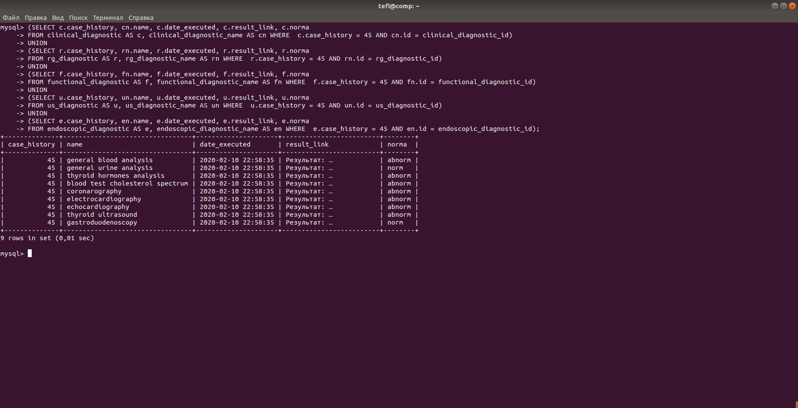

1. Запрос, выводящий по названию заболевания лекарственные препараты прописанные в рекомендациях.

SELECT m.illness, d.active_substance, d.tradename

FROM MKB_10_drug AS md

RIGHT JOIN MKB_10 AS m ON m.code = md.MKB_10_code

RIGHT JOIN drug AS d ON d.id = md.drug_id

WHERE md.MKB_10_code = 'I21'

ORDER BY active_substance;

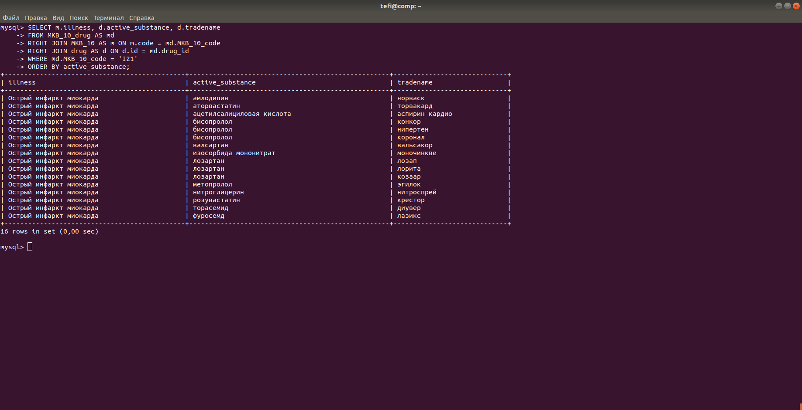

1. Представления, выводящие список ФИО медперсонала и специальность, отсортированные по фамилии или специальности.

CREATE OR REPLACE VIEW med_staff_surname AS

SELECT m.surname, m.name, m.patronym, s.name AS specialty FROM medical_staff AS m, specialty AS s WHERE s.id = m.specialty_id ORDER BY m.surname;

SELECT * FROM med_staff_surname;

CREATE OR REPLACE VIEW med_staff_specialty AS

SELECT m.surname, m.name, m.patronym, s.name AS specialty FROM medical_staff AS m, specialty AS s WHERE s.id = m.specialty_id ORDER BY s.name;

SELECT * FROM med_staff_specialty;

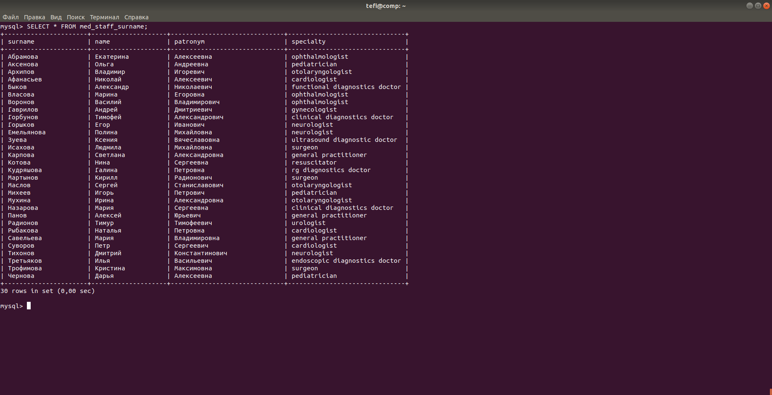

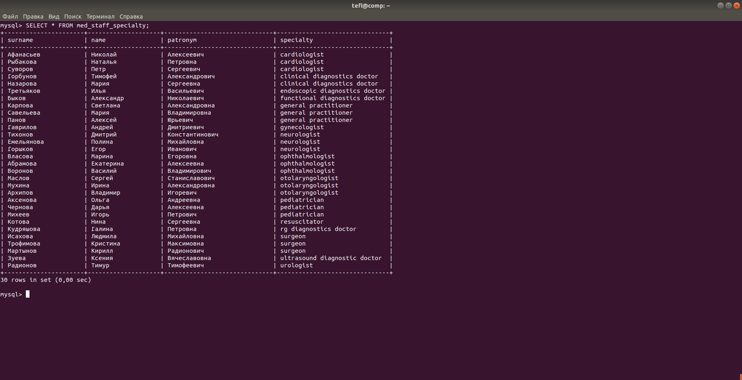

1. Представления, выводящие список пациентов, находящихся на диспансерном наблюдении (с названиями заболеваний и с кодами)

CREATE OR REPLACE VIEW dispansery_MKB_illness AS

SELECT d.case_history, m.illness, s.name AS specialty FROM dispansery_observation AS d, MKB_10 AS m, specialty AS s WHERE s.id = d.specialty_id AND m.code=d.MKB_10_code ORDER BY s.name \G;

SELECT * FROM dispansery_MKB_illness;

CREATE OR REPLACE VIEW dispansery_MKB_code AS

SELECT d.case_history, d.MKB_10_code, s.name AS specialty FROM dispansery_observation AS d, specialty AS s WHERE s.id = d.specialty_id ORDER BY s.name;

SELECT * FROM dispansery_MKB_code;

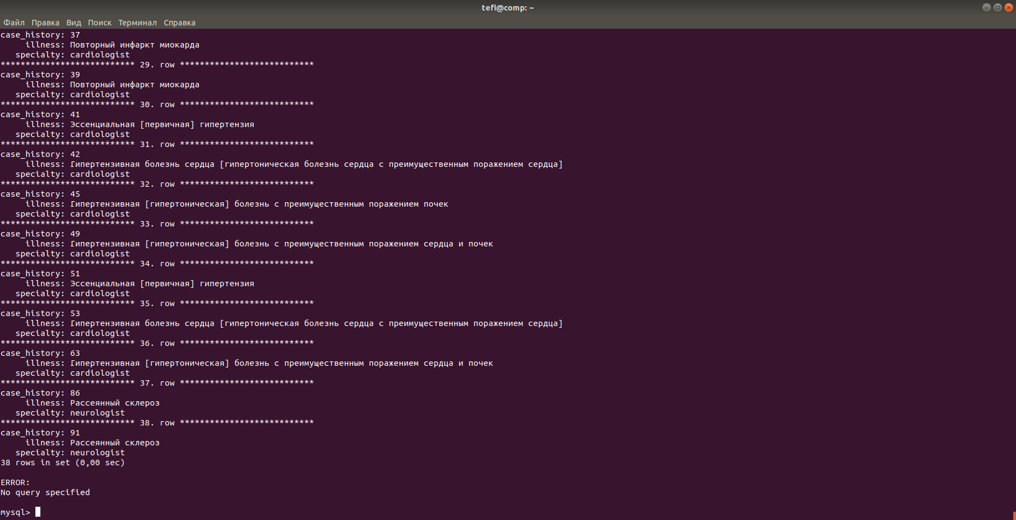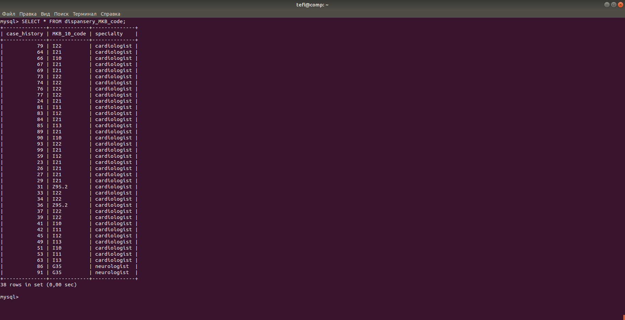

1. Процедура, возвращающая количество пациентов с данным кодом хронического заболевания.

DELIMITER //

CREATE PROCEDURE history_MKB_code (cod VARCHAR(15))

BEGIN

SELECT COUNT(c. case_history) FROM chronic_illness AS c WHERE c.MKB_10_code=cod;

END//

CALL history_MKB_code ('I10');

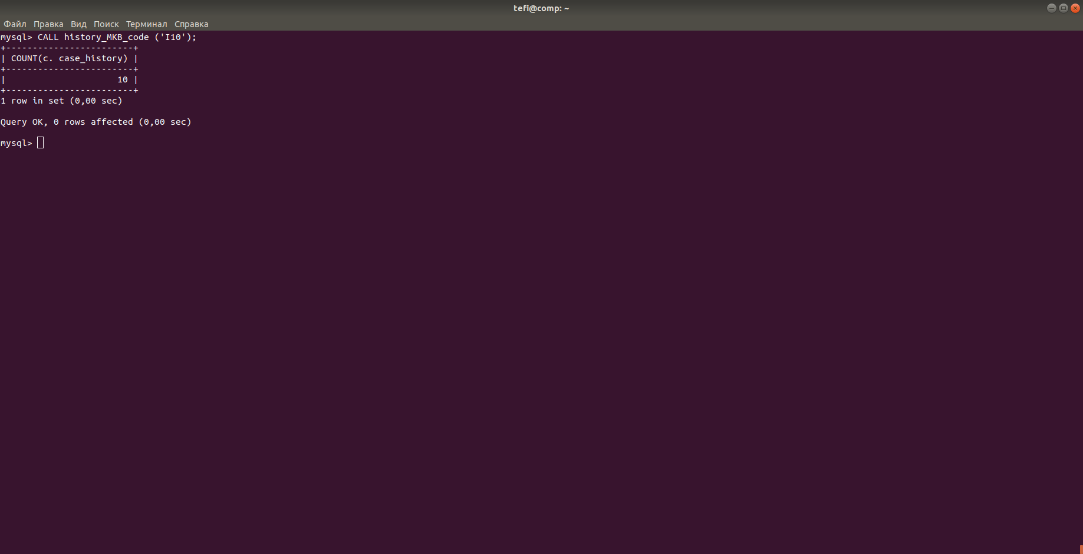

1. Триггер, запрещающий удаление подотчетных листов нетрудоспособности.

CREATE TRIGGER sick_list_del BEFORE DELETE ON sick_list

FOR EACH ROW

BEGIN

SIGNAL SQLSTATE '45000' SET MESSAGE_TEXT = 'DELETE NOT PERMITED';

END//

DELETE FROM sick_list LIMIT 1;

ERROR 1644 (45000): DELETE NOT PERMITED

